**Enterprise Resource Planning**

**User Manual**

**VERSION 12.0.0**

**INVENTORY**

**(Store Transfer & Receive)**

**Index**

|  |  |
| --- | --- |
| **About** | **Page No.** |
| * Transfer Order Entry | **03** |
| * Superior Setup | **06** |
| * [Transfer Approval](http://localhost:8080/zab/login?screen=imtorheaderapp&option=Transfer+Approval&menuname=imreqall) | **07** |
| * Transfer & Receive Confirmation | **09** |
|  |  |

* Transfer Order Entry

## Header Entry

|  |  |
| --- | --- |
| **Step 1** | Open System **>** Inventory **>** Transfer Order Entry |
| **Step 2** | Define the From Store & To Store Code. |
| **Step 3** | Write the Justification |
| **Step 3** | Click **Add**. |
| **Result** | A new TO will be created |

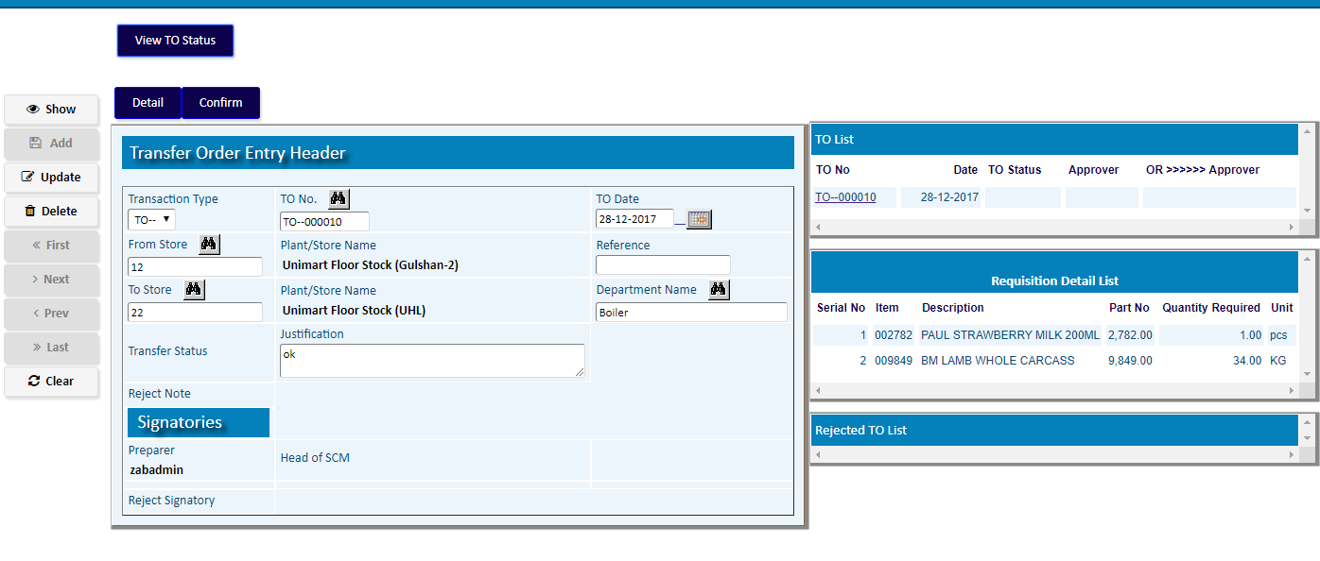

## Detail Entry

|  |  |
| --- | --- |
| **Step 1** | Click **Detail** |
| **Step 2** | Pick Item Code From the list |
| **Step 3** | Fix the Serial / Box type |
| **Step 4** | Click **Add** to add the Item record. |
| **Result** | Click **Return** to back to TO header |

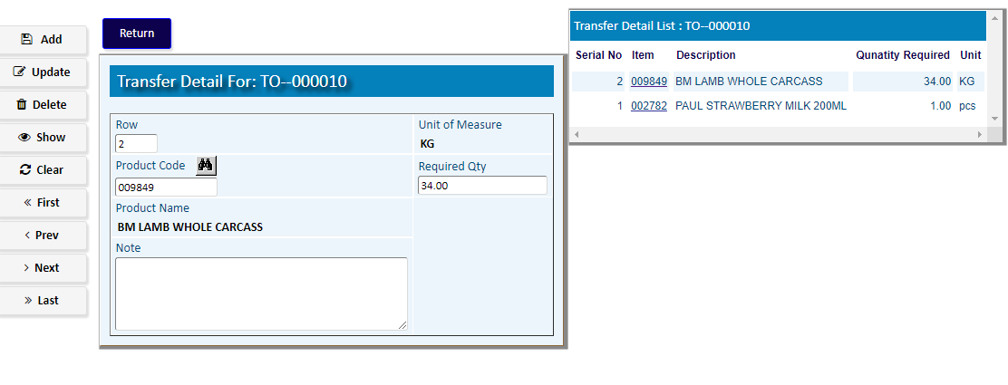

**\*\*)** Click **Confirm** to Confirmthe Transfer Order



**For the superiors of Entry User**

((For set the user’s superiors for ‘TO Approval’ go to the Option:

**Main Menu >** [**Administrations**](javascript:run1()&menuname=com) > [**Master Setup**](javascript:run1()&menuname=cacodes) > [**Approval Setup**](javascript:run1()&menuname=apvsetup) > [Superior Setup](http://localhost:8080/zab/login?screen=pdsuperior&option=Superior+Setup&menuname=apvsetup) ))

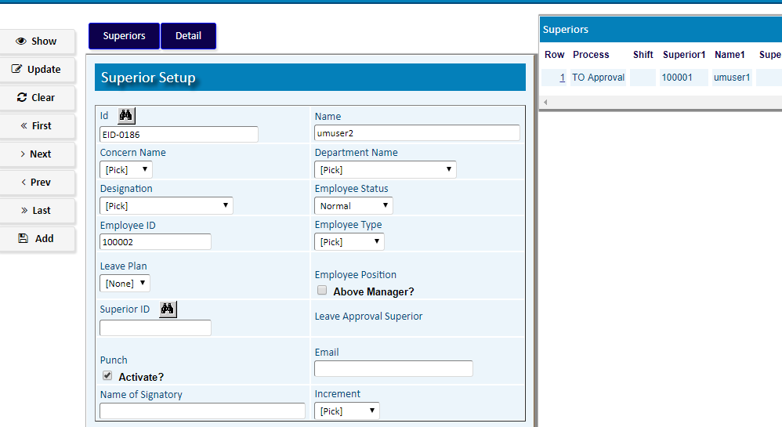

* [Transfer Approval](http://localhost:8080/zab/login?screen=imtorheaderapp&option=Transfer+Approval&menuname=imreqall)

|  |  |
| --- | --- |
| **Step 1** | Open System **>** [**Main Menu > Requisition**](javascript:run1()&menuname=imreqall) **>** [Transfer Approval](http://localhost:8080/zab/login?screen=imtorheaderapp&option=Transfer+Approval&menuname=imreqall) |
| **Step 2** | Pick the TO number from side list |
| **Step 3** | Click **Detail** and **Show/Update** the **Item/ Qty** to approve partially |
| **Step 4** | Click **Return** |
| **Step 5** | Click **Approve** button to Approve the TO or **Reject** button to reject |
| **Result** | The TO will be Approved / Rejected |

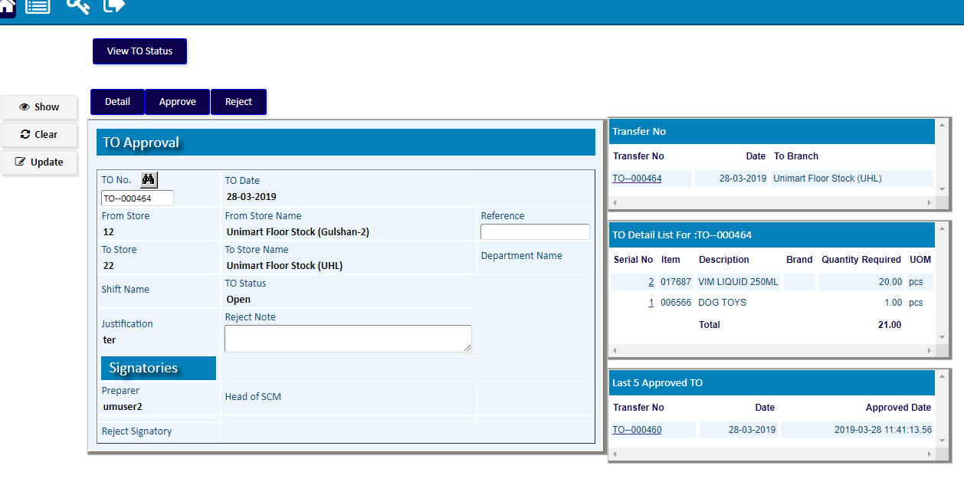

Approval Detail

Click **Detail** and **Show/Update** the **Item/ Qty** to approve partially

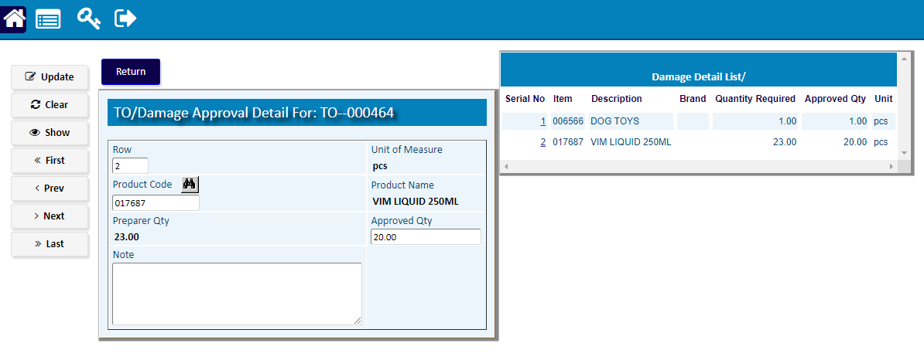

* Transfer & Receive Confirmation

To **Check Stock/ Transfer /Receive**

Go to the option >>

Main Menu > Approver Notifications

Or

Main Menu > Inventory > Notifications

Or

Main Menu > Inventory > Transfer & Receive Confirmation

1. **Check Stock**

|  |  |
| --- | --- |
| **Step 1** | Pick the TO number from Side list to **Show** |
| **Step 2** | Click **Check Stock** buttonand **Check** the **Item / Qty** Availability |
| **Result** | The Item Quantity will be checked within Stock Availability of From Store |

1. **Transfer to Store**

|  |  |
| --- | --- |
| **Step 1** | Pick the TO number to **Show** |
| **Step 2** | Click **Transfer** buttonto  **Transfer to store** |
| **Result** | The **TO** items will be transferred From Store > To Store |

1. **Receive to Store**

|  |  |
| --- | --- |
| **Step 1** | Pick the TO number to **Show** |
| **Step 2** | Click **Receive** buttonto  **Receive to store** |
| **Result** | The items of the **TO** will be **Received** by ‘To Store’ |

